Overexposed Image Enhancement System by Using Integration of 3 Enhancement Methods

Gabriel Dennis Mathematics Computer Graphics Programme
Faculty of Science and Natural Resources Universiti Malaysia Sabah
Kota Kinabalu, Sabah, Malaysia
gabriel_dennis_bs21@iluv.ums.edu.my Abdullah Bade Mathematics Computer Graphics Programme
Faculty of Science and Natural Resources Universiti Malaysia Sabah
Kota Kinabalu, Sabah, Malaysia
abb@ums.edu.my

Abstract— Overexposure during image capture can negatively impact image quality and make processing difficult for computer vision systems. Computational photography, widely used in smartphones, helps improve image quality by automating enhancements like professional cameras. This research applies the Dark Channel Prior (DCP) method combined with non-local means denoising and unsharp masking to address overexposure issues. Unsharp masking sharpens lost details, while image quality is evaluated using PSNR, SSIM, entropy, and the Colorfulness Index (CI). The results show improvements in entropy and CI, indicating better visual quality, though PSNR and SSIM values are lower due to the lack of high-quality reference images. Overall, this study offers promising insights for restoring images affected by motion blur, with potential for further improvements in future research.
Keywords — overexposed image, DCP, non-local means denoising, unsharp masking

Introduction
In the era of globalization filled with advanced technology, images play a crucial role in devices such as computers and smartphones. Nicéphore Niépce, a French scientist, invented photography in 1825, and Louis Daguerre perfected it in the 19th century. Images have become an effective tool for conveying information because the human brain processes visual information more easily than text, according to [2]. Smartphones, popular due to their compact size and multifunctionality, including taking photos, still lag in quality compared to DSLR cameras. DSLRs have better sensors and lenses, producing higher-quality images compared to smartphone [7]. However, image processing through applications like Snapseed and Adobe Photoshop Express can enhance the quality of smartphone images.
Computational photography, uses algorithms to improve the quality of smartphone images, making them nearly comparable to DSLRs [28]. Computational photography is the process that run automatic, enhancing image quality before, during, and after capturing the image.
Overexposed images refer to images that are exposed to excessive light, causing the image to be unclear and lose details. This can occur due to the camera sensor being too sensitive, the photographer's position, or the high ISO setting on a smartphone [9]. One of the main problems is overexposure, which causes image noise, especially in the darker areas, altering the colors of the image and making it difficult to interpret information. The post-processing of the image becomes more difficult because the image quality needs to be restored, requiring expertise in computational photography [17]. Additionally, excessive lighting can reduce the aesthetic value of the image, affecting emotional responses and the acceptance of the image on social media [11].
This study addresses the issue of overexposed images, which are caused by factors like incorrect camera settings, bright lighting, or inaccurate exposure, leading to excessive brightness and loss of detail. The goal is to develop a system for recovering high-intensity images using an improved Dark Channel Prior (DCP) technique, Non-Local Means Denoising, and unsharp masking.

LITERATURE REVIEW

Digital Tmage
A digital image is made up of a grid of pixels, each of which represents a distinct place and has color and intensity numbers. Pixels in an image are comparable to grid cells in spatial analysis, claims [12]. The RGB color paradigm, in which each pixel's color is a mixture of red, green, and blue intensity values, is frequently used in digital photographs. Because it offers hundreds of hues instead of only a few grayscale tones, this model is frequently utilized for object detection and scene extraction [15]. Bit depth, typically 8-bit or 24-bit, controls how many bits are used to represent the color of each pixel. By eliminating unnecessary information, image compression minimizes file size while preserving the original's resolution and visual quality [23].

Overexposed Image
Overexposed image is an image when too much light hits the camera sensor, it creates glare and appears washed out. Achieving the proper exposure is essential for balanced, aesthetically pleasing photos without sacrificing significant details. Exposure in photography refers to the quantity of light that the camera records over time. Significant color shifts might result when correcting overexposed photos, changing their appearance from the original scenario. Strong sunshine during the day can obscure details and lessen contrast, making overexposure difficult. Long exposure lengths at night can result in excessive brightness, which can impair image clarity by reducing contrast, reducing detail, and increasing digital noise.

Image Processing
Image processing involves improving image quality, analyzing images, and applying mathematical and computational techniques using various devices and applications [27]. This field covers a wide range of tasks, from basic operations like image enhancement and restoration to advanced applications such as object detection and recognition. Image enhancement improves visual quality by adjusting contrast, brightness, and sharpness, making useful information more prominent while minimizing irrelevant details [19]. Image restoration focuses on reconstructing degraded images using numerical analysis and filtering techniques [3]. Beyond visual improvements, image processing is essential for compression, which reduces storage space and enhances image transmission while preserving quality. Feature extraction identifies key structural and textural properties, such as edges, corners, and contours, for further classification, recognition, and detection [18]. Object detection and recognition algorithms locate and identify specific patterns in images, supporting applications such as facial recognition, vehicle tracking, defect detection, and autonomous navigation. As mathematical techniques and algorithms continue to evolve, image processing plays a growing role in understanding visual information, enabling new possibilities, and transforming how we interpret and interact with digital imagery.

Computational Photography
Computational photography is an interdisciplinary field that combines computer vision, computer graphics, signal processing, and optics to overcome the limitations of traditional digital imaging [24]. It transforms how images are captured, processed, and manipulated, enabling photographers to achieve results that are impossible with conventional optical systems. Computational photography develops new algorithms and systems to enhance image capture, overcoming conventional limitations and recovering lost details [10].. This field integrates advanced algorithms to significantly improve digital imaging beyond traditional constraints. Image alignment ensures accurate stitching and blending of multiple images, correcting camera movement or scene changes [25]. Computational zoom uses super-resolution algorithms to generate high-resolution images, surpassing the limits of optical zoom [16]. Depth estimation and 3D reconstruction leverage techniques like stereo vision and light field photography to infer depth from 2D images and create accurate 3D scene models [22]. Additionally, image inpainting and denoising restore missing or damaged parts of an image while preserving important details using advanced statistical models and machine learning algorithms [5].

DCP
The Dark Channel Prior (DCP) is a widely used method for image dehazing [14]. It is based on the observation that in most outdoor, haze-free images, at least one color channel has very low intensity in non-sky regions. This property helps estimate haze thickness and recover a clearer image. The method identifies the dark channel by finding the lowest intensity among the RGB channels in local patches. The haze imaging model represents an image as a combination of scene radiance and atmospheric light, adjusted by a transmission map, which determines how much light reaches the camera. The transmission map is first estimated using the dark channel and then refined with guided filtering to preserve edges [14].
Many improvements have been made to enhance DCP. A denoised method was developed a non-local dehazing method to reduce halo artifacts and preserve details [4], while a fast dehazing algorithm using color attenuation priors to improve speed was introduced [29]. Deep learning has further advanced dehazing techniques, with models like DehazeNet [8] and multi-scale convolutional networks [20] achieving better results.
Using in-depth information has also improved dehazing. Data from stereo images or depth sensors helps refine the transmission map, especially in scenes with varying depths [26]. Combining DCP with other priors, such as the color-lines prior or boundary constraints, has led to even better results by leveraging multiple image properties [1].

Non-Local Means Denoising
The non-local means denoising algorithm, introduced by [6] is a method for reducing noise in images. Unlike traditional techniques such as average filtering or Gaussian filtering, which rely on spatial proximity, this approach considers similarity in intensity patterns across the entire image. The algorithm replaces each pixel's intensity with a weighted average of other pixels that have similar local patches. The weights are determined based on the Gaussian-weighted Euclidean distance between patches. A key advantage of this method is its ability to preserve fine details and textures better than local filtering techniques, making it particularly useful in applications such as medical image restoration and digital photography [6].

Unsharp Masking
Unsharp masking is an image sharpening technique designed to enhance visual clarity by emphasizing edge details through high-frequency processing. The process begins by creating a blurred version of the original image using a low-pass filter, such as Gaussian blur, which removes fine details and high-frequency components. A sharpening mask is then generated by computing the difference between the original and blurred images, highlighting edges and subtle details. This mask is multiplied by a scaling factor to control the sharpening intensity before being added back to the original image. As a result, edge contrast is increased, making the image appear sharper and clearer, while homogeneous areas (such as backgrounds) remain unaffected. This technique is widely used in digital photography, printing, and medical imaging, as it effectively enhances image clarity without significantly increasing noise, making it a valuable tool for visual quality enhancement [13]

METHODOLOGY
This part discusses a number of methodologies that are crucial to the research, such as input, processing and evaluation metric used in this study. There are three key components in the development of this system: input, process, and output. As shown in the diagram below, these components are interdependent to achieve a satisfactory output through the applied methods.
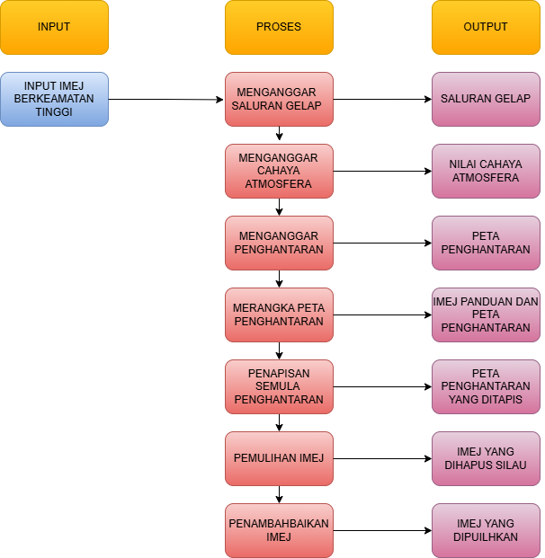
Figure 2.1

Input
In this study, the input images are sourced from a dataset by Mahmoud Afifi (2020), which consists of images collected from various photographers on websites like Flickr. The system allows any image to be used as input, as the dataset contains images of varying sizes, all maintained in RGB format. However, to ensure faster and more efficient image processing, the maximum image size is set to 800 × 600 pixels. This size limitation helps optimize processing speed, but it does not apply to high-resolution images.

Process
At this stage of the study, several digital image processing methods will be applied to enhance high-intensity images. Each technique plays a role in restoring the image. The role of the Dark Channel Prior (DCP) technique in this system is to reduce glare and recover lost details in the image. First and foremost, DCP are applied to remove overexposed image in input image as below:
$$I\left(x\right)=J\left(x\right)t\left(x\right)+A\left(1-t\left(x\right)\right) (1)$$
Where $I(x)$ represents the image affected by glare, $J(x)$ denotes the glare-free image, $A$ refers to the atmospheric light intensity, and $t(x)$ represents the transmission.

- Extract Dark Cahnnel
The dark channel is computed by taking the minimum intensity value of pixels across the three color channels (B, G, R). This concept is based on the observation that, in most non-sky regions, at least one color channel has a low intensity. This step can be expressed by the following equation:
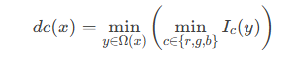 (2)
Where $I_{c}(y)$ represents the pixel intensity in color channel $c$ (red, green, or blue) at position $y$, $Ω(x)Ω(x)$denotes the neighborhood region around pixel 𝑥 and $dc\left(x\right)$ is the dark channel value at position 𝑥. Morphological erosion is applied to suppress noise and refine the dark channel, as expressed in the following equation:
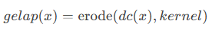 (3)
Where the $kernel$ is the structural element used in morphological operations.

- Atmospheric Light Estimation
Atmospheric light value, $A$ estimated by selecting the top $0.1\%$ from the brightest pixel in dark channel and computing the average intensity of these pixels in the original image.
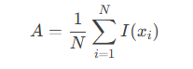 (4)
Where $N$represents the number of selected pixels (0.1% of the total pixels), $I({x​}_{i})$denotes the intensity value of the $i$-th pixel in the original image, and $A$ is a 3D vector representing the atmospheric light for each color channel (B, G, R). The atmospheric light is then normalized by dividing each component of A by its maximum value:
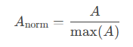 (5)

- Transmission Estimation
In this step, the transmission map $t(x)$ is estimated, representing the portion of light that is not absorbed or scattered by the atmosphere. The transmission map is computed by normalizing the original image with atmospheric light and subtracting the dark channel multiplied by the parameter $ω$, as expressed as:
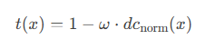 (6)
Where ${dc}_{norm}​(x)$ is dark channel normalized by the atmospheric light as below:
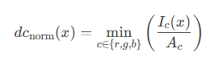 (7)
Meanwhile, $ω$is a control parameter (typically set to 0.95) that determines the degree of overexposed effect removal.

- Designing Guided Filter
This function filters the transmission map using a guidance image (typically the grayscale version of the original image) to produce a smoother and more consistent transmission map. In equation (8), the guided filter applies a local linear model:
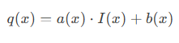 (8)
Where $I(x)$ ialah guidance image and $a(x)$ dan $b(x)$ are linear model parameters computed from the covariance and variance:
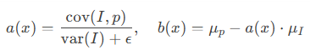 (9)
where $cov(I,p)$ is the covariance between the guidance image $I$ and transmission map $p$. $var(I)$ is the variance of the guidance image. $μ_{i}$​ dan $μ_{p}$​ represent the local means of guidance image and the transmission map, respectively. The parameter $ϵ$ is a regularization term to prevent division by zero.

- Refining Transmission map
As expressed in equation (10), the transmission map is refined using a guided filter with the grayscale version of the original image as the guidance image.
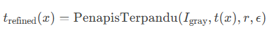 (10)
Where $I_{gray}$ represents the original image in grayscale, $t(x)$ is the initial transmission map, $r$ is the filter radius and$ϵ$ is a regularization parameter.

- Image Restoration
The overexposed effects are removed from the image using the transmission map and atmospheric light obtained in Steps b and e, as expressed in equation (11):
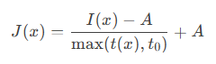 (11)
$I(x)$ is input imej, $A$ is atmospheric light, $t(x)$ is transmission map and $t_{0}$ is a threshold value (typically 0.1) to prevent division by excessively small values. Restored image, $J(x)$ is then clipped to the range [0,1] to ensure valid pixel values.

- Image Enhancement
Finally, all the above steps are combined to further improve the image using bilateral filtering, non-local means denoising, and sharpening with the unsharp masking technique. This process begins with the application of bilateral filtering, noise removal (Non-Local Means Denoising), and unsharp masking, as described in the following equations.
Bilateral Filtering:
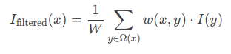 (12)
where $w(x,y)$ is a weighting function that depends on spatial distance and intensity difference, and $W$ is a normalization factor.

Non-Local Means Denoising:
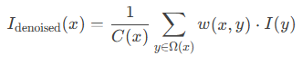 (13)
Where $w(x,y)$ is a weight that depends on the similarity between neighborhood regions, and $C(x)$ is a normalization factor.
Unsharp masking:
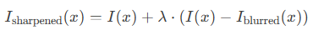(14)
Where$I_{blurred}(x)$ s the Gaussian-blurred image, and $λ$ s a sharpening parameter. By combining all the above functions and equations, the resulting image will have improved quality with reduced haze, sharper details, and minimized noise.

Result and Discussion
This section will discuss about the result gain and the analysis for the proposed method, DCPX3. There are 4 evaluation metric used in this section which are:
- Peak Signal Noise Ratio, PSNR
PSNR is used to calculate the ratio between the maximum possible signal power and the power of the noise affecting the quality of the output image. PSNR is also typically calculated on a logarithmic decibel scale due to the wide dynamic range of signals. This dynamic range varies between the maximum and minimum values, which can change depending on the quality of an image. The formula for PSNR is as follows[]:
$$PSNR=10\log_{10}\left[\frac{M^{2}}{MSE}\right] (15)$$
Where $M$ refers to the maximum pixel value in an image.
- Structural Similarity Index, SSIM
SSIM is a metric that measures the structural similarity between a restored image and the original image. This metric assesses image quality based on structural differences, brightness, and contrast in an image. The formula for SSIM
can be defined as follows []:
$$SSIM= \frac{(2μ_{x}μ_{y} + C_{1})(2σ_{xy} + C_{2})}{{(μ}_{x}^{2}+ μ_{y}^{2}+ C_{1})(σ_{x}^{2} + σ_{y}^{2} + C_{2})} (16)$$
where $μ_{x}$ and $μ_{y}$ are the pixel averages, while $σ_{x}$ and $σ_{y}$are the pixel standard deviations in the original image and the restored image, respectively. $C_{1}$ and $C_{2}$ are constants to ensure a linear response in the formula to prevent division by
zero in undesired cases.

- Entropy
Entropy is used to measure the amount of information in an image [13]. The entropy calculation is expressed as follows:
$$entropy= \sum_{k=0}^{L-1}{p_{k}.\log_{2}{p_{k}} (17)}$$
where $L$ is the level of gray scale in the image, and $P_{k}$ is the probability of obtaining a certain gray scale level.
- Colorfulness Index, CI
Colorfulness Index, CI is typically calculated based on the statistical characteristics of color channels in an image. One common method to compute it involves the following step:
- Change image to RGB
- Calculate different between red channel (R), green channel (G) and blue channel (B).
- $rg=R-G$
- $yb=\frac{1}{2}(R+G)-B$
- Calculate mean ($μ$) and standard deviation ($σ$) for value $rg$ and $yb$.
- $μ_{rg}$​: Mean $rg$
- $μ_{yb}$​: Mean $yb$
- $σ_{rg}$​: Standard deviation $rg$
- $σ_{yb}​:$ Standard deviation $yb$
- Calculate CI by following formula:
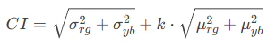 (18)
Table 1 List of Input Images
Sample | Input Image | Sample | Input Image
STD01 | 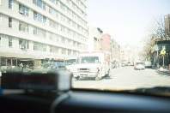 | STD06 | 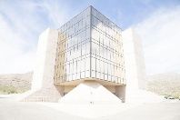
STD02 | 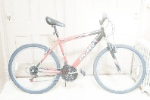 | STD07 | 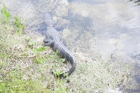
STD03 |  | STD08 | 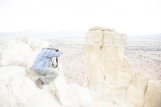
STD04 |  | STD09 | 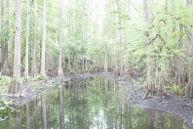
STD05 | 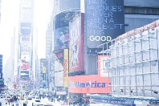 | STD10 | 

Each of the sample undergoes same process flow by the proposed method, DCPX3. The process is extract the dark channel from input image, estimate atmospheric light and tranmission map, then designed the guided filter and with that filter, we refined the transmission map. Finally, by all the value from previous step, the image will restore from overexposed image. To produced more better image, the image enhance by non-local means denoising and unsharpmasking. Table 2 will show the comparision of ground truth, output image of original DCP and output Image from DCPX3.
Table 2 Imej Output
Sample | Ground Truth | DCP | DCPX3
STD01 | 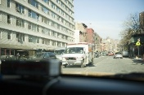 |  | 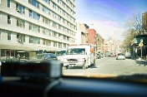
STD02 |  |  | 
STD03 |  |  | 
STD04 | 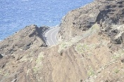 |  | 
STD05 | 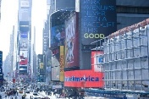 | 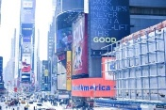 | 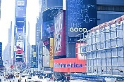
STD06 | 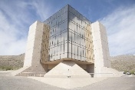 | 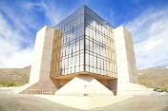 | 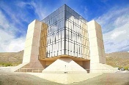
STD07 | 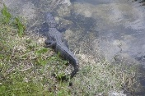 |  | 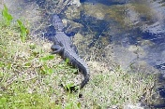
STD08 | 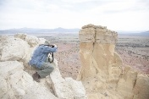 | 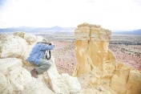 | 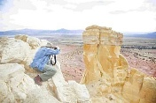
STD09 | 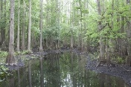 | 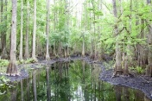 | 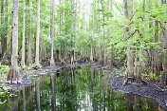
STD10 |  |  | 
Upon visual inspection, it can be observed that the details and
contrast of the output image for DCPX3 is better than original DCP. This is due to the combination application of non-local means denoising and unsharp masking which enhances the overall appearance of the image.
Table 3 Comparison PSNR and SSIM value
Sample | PSNR DCP | PSNR DCPX3 | SSIM DCP | SSIM DCPX3
STD01 | 18.61947155 | 16.55452768 | 0.87311778 | 0.783218248
STD02 | 17.22089983 | 14.89747349 | 0.851073234 | 0.723272264
STD03 | 14.51152872 | 13.49004576 | 7.394589717 | 0.730659566
STD04 | 17.95471379 | 14.21308729 | 0.766154265 | 0.59767038
STD05 | 16.1180689 | 14.7989298 | 0.883938424 | 0.755600421
STD06 | 14.82995722 | 12.54005721 | 0.834318698 | 0.70454194
STD07 | 16.2800973 | 12.11601216 | 0.827650495 | 0.700701124
STD08 | 17.98588081 | 16.01509375 | 5.113008547 | 0.730707589
STD09 | 15.51913314 | 14.53782792 | 0.862102728 | 0.71010083
STD10 | 12.68668909 | 10.74024276 | 0.711821235 | 0.562364272

Based on the table, PSNR and SSIM value for DCPX3 is basically lower than the original DCP. It is because both evaluation metrics are dependent to ground truth image. Since the ground truth image from the dataset is not of the highest quality, it may occur some error in the result. That why there are two more evaluation metrics that not dependent to the ground truth image. The following table shows the entropy CI value:

Table 4 Entropy and CI Value for Input Image and Output Image
Sample | Entropy Input | Entropy Output | CI Input | CI Output
STD01 | 7.326024938 | 7.7713436 | 18.92191353 | 40.6643523
STD02 | 5.433129814 | 6.677162727 | 11.79658869 | 30.08246449
STD03 | 7.394589717 | 7.588740427 | 18.91862013 | 30.94107575
STD04 | 5.767835 | 7.005351047 | 15.89064634 | 50.93201786
STD05 | 7.117550036 | 7.453253963 | 41.39909778 | 66.14624168
STD06 | 5.945326137 | 7.355912005 | 21.9283261 | 66.47674469
STD07 | 6.657275488 | 7.443976323 | 27.61226661 | 44.00499983
STD08 | 5.113008547 | 5.855275272 | 13.92675862 | 38.74777797
STD09 | 7.204416054 | 7.687401359 | 21.75792534 | 39.28046332
STD10 | 7.04388929 | 7.642662934 | 21.28993295 | 54.28269861
Based on table 4, it show some significant increase value of entropy that mean that there most of detail have been retrieved from the input image. Improvement value of CI also means that the output image details have retrieved their color from the proposed method, DCP. This show that even PSNR and SSIM value of the proposed method lower than the original method, but it retrieved more detailed information of the image in term of edges and color. Sometime, noise and similarity to the ground truth could be sacrifice in order to obtain more detailed image.

Conclusion
The developed system is enhancing overexposed image by the combination of DCP method, non-local means denoising and unsharp masking. This study not only to remove the overexposed effect from image, but also reduce noise and improve detailed of the image. Testing involves various overexposed image measurement techniques. The significance lies in addressing challenges related to overexposed effect in image restoration, offering a valuable solution for computational photography. The importance is evident in potential applications, such as medical imaging and surveillance, where clear and sharp images are essential for accurate analysis.

Acknowledgement
I would like to express my gratitude to my supervisor, Prof. Dr. Abdullah, for providing guidance and assistance throughout the period of my dissertation. I would also like to express my gratitude to my family and friends who provided me support during my final year project. This study would not have been possible without their assistance.

References
- Ancuti, C. O., Ancuti, C., De Vleeschouwer, C., & Bekaert, P. (2012). Single ImageDehazing by Multi-Scale Fusion. IEEE Transactions on Image Processing, 22(8), 3271-3282. https://ieeexplore.ieee.org/abstract/document/6514885.
- Balm J. , 11 Ogos 2014, The Power of Pictures, How We Can Use Images to Promote and Comunicate Science. BMC https://blogs.biomedcentral.com/bmcblog/2014/08/11/the-power-of-pictures-how-we-can-use-images-to-promote-and-communicate-science/.
- Banham, M., & Katsaggelos, A. (2012). Digital image restoration. IEEE Signal Process. Mag., 14, 24-41. https://doi.org/10.1109/79.581363.
- Berman, D., & Avidan, S. (2016). Non-Local Image Dehazing. Proceedings of the IEEE Conference on Computer Vision and Pattern Recognition (CVPR). https://openaccess.thecvf.com/content_cvpr_2016/html/Berman_Non-Local_Image_Dehazing_CVPR_2016_paper.html.
- Bertalmío, M., Sapiro, G., Caselles, V., & Ballester, C. (2000). Image inpainting. Proceedings of the 27th Annual Conference on Computer Graphics and Interactive Techniques (SIGGRAPH), 417-424. https://dl.acm.org/doi/abs/10.1145/344779.344972.
- Buades, A., Coll, B., & Morel, J. M. (2005). A non-local algorithm for image denoising. IEEE Computer Society Conference on Computer Vision and Pattern Recognition (CVPR), 60-65. https://ieeexplore.ieee.org/abstract/document/1467423
- Butrym N. , 19 September 2022, What is The Future of Photography? Smartphone or DSLR? – 5 Things a DSLR Does Better Than a Phone Camera. DeepImage https://deep-image.ai/blog/what-is-the-future-of-photography-smartphones-or-dslr-5-things-a-dslr-does-better-than-a-phone-camera/.
- Cai, B., Xu, X., Jia, K., Qing, C., & Tao, D. (2016). DehazeNet: An End-to-End System for Single Image Haze Removal. IEEE Transactions on Image Processing, 25(11), 5187-5198. https://ieeexplore.ieee.org/abstract/document/7539399.
- Chechko A. , 24 January 2024, Overexposed Image: How to Fix Them. Skylum https://skylum.com/how-to/how-to-fix-overexposed-photos.
- Chen, M., & Shannon, C. (2018). Computational Photography. Photography. https://doi.org/10.1364/is.2010.iwb2.
- Davies P. , 20 Mac 2023, The Psychology of Aesthetics and Style: How We are Attracted to These Notion. Player https://play3r.net/news/the-psychology-of-aesthetics-and-style-how-we-are-attracted-to-these-notions/.
- Fisher, P. (1997). The pixel: A snare and a delusion. International Journal of Remote Sensing, 18, 679-685. https://doi.org/10.1080/014311697219015.
- Gonzalez, R. C., & Woods, R. E. (2018). Digital Image Processing. Pearson.
- He, K., Sun, J., & Tang, X. (2009). Single Image Haze Removal Using Dark Channel Prior. IEEE Transactions on Pattern Analysis and Machine Intelligence, 33(12), 2341-2353. https://ieeexplore.ieee.org/abstract/document/5567108.
- Kumar, T., & Verma, K. (2010). A Theory Based on Conversion of RGB image to Gray image. International Journal of Computer Applications, 7, 5-12. https://doi.org/10.5120/1140-1493.
- Liu, D., Wang, Z., Fan, Y., Liu, X., Wang, Z., Chang, S., & Huang, T. S. (2017). Robust Single Image Super-Resolution via Deep Networks with Sparse Prior. IEEE Transactions on Image Processing, 25(7), 3194-3207. https://ieeexplore.ieee.org/abstract/document/7466062.
- Ljubisavijevic M. , 20 November 2018, Tips of the week: Adjusting exposure i post processing. DreamsTime https://www.dreamstime.com/blog/tip-week-adjusting-exposure-post-processing-51136.
- Mutlag, W., Ali, S., Aydam, Z., & Taher, B. (2020). Feature Extraction Methods: A Review. Journal of Physics: Conference Series, 1591. https://doi.org/10.1088/1742-6596/1591/1/012028.
- Qi, Y., Yang, Z., Sun, W., Lou, M., Lian, J., Zhao, W., Deng, X., & Ma, Y. (2021). A Comprehensive Overview of Image Enhancement Techniques. Archives of Computational Methods in Engineering, 29, 583-607. https://doi.org/10.1007/S11831-021-09587-6.
- Ren, W., Liu, S., Zhang, H., Pan, J., Cao, X., & Yang, M.-H. (2016). Single Image Dehazing via Multi-Scale Convolutional Neural Networks. Proceedings of the European Conference on Computer Vision (ECCV). https://ieeexplore.ieee.org/abstract/document/7539399.
- Sara, U., Akter, M., & Uddin, M. S. (2019). Image quality assessment through FSIM, SSIM, MSE and PSNR—A comparative study. Journal of Computer and Communications, 7(3), 8–18. https://doi.org/10.4236/jcc.2019.73002
- Seitz, S. M., Curless, B., Diebel, J., Scharstein, D., & Szeliski, R. (2006). A comparison and evaluation of multi-view stereo reconstruction algorithms. Proceedings of the 2006 IEEE Computer Society Conference on Computer Vision and Pattern Recognition (CVPR), 519-528. https://ieeexplore.ieee.org/abstract/document/1640800.
- Subramanya, A. (2001). Image compression technique. IEEE Potentials, 20, 19-23. https://doi.org/10.1109/45.913206
- Suo, J., Ji, X., & Dai, Q. (2012). An overview of computational photography. Science China Information Sciences, 55, 1229 - 1248. https://doi.org/10.1007/s11432-012-4587-6..
- Szeliski, R. (2006). Image alignment and stitching: A tutorial. Foundations and Trends in Computer Graphics and Vision, 2(1), 1-104. https://www.nowpublishers.com/article/Details/CGV-009.
- Tang, K., Yang, J., & Wang, J. (2014). Investigating Haze-Relevant Features in a Learning Framework for Image Dehazing. Proceedings of the IEEE Conference on Computer Vision and Pattern Recognition (CVPR). https://openaccess.thecvf.com/content_cvpr_2014/html/Tang_Investigating_Haze-relevant_Features_2014_CVPR_paper.html.
- Vijaya, P. (2013). Electronics and Digital Computing Techniques for Images and Image Processing. , 37-45. https://doi.org/10.1007/978-81-322-1524-0_8.
- Wankhede C. , 12 Februari 2023, What is Computer Photography and Why Does It Matter? Android Authority https://www.androidauthority.com/what-is-computational-photography-3218656/.
- Zhu, Q., Mai, J., & Shao, L. (2015). A Fast Single Image Haze Removal Algorithm Using Color Attenuation Prior. IEEE Transactions on Image Processing, 24(11), 3522-3533. https://ieeexplore.ieee.org/abstract/document/7128396

